**Health Monitor Error log**

During the testing and development of my health monitor I encountered a few bugs, these temporarily halted my overall progress., but eventually I was able to work around and solve them.

1. One error I uncovered was that while coloring in the text, the next line under was also colored in the same color, even if I didn’t intend for it to be. I solved this by resetting the color code after every colored line of code, this was achieved using ‘[**0m**’ after the color code on the line that I intend to be colored.



1. Another error that was encountered was that after the results were displayed the user didn’t receive an overview of all of their results from their vitals. This was fixed by outputting a summary of the results for their vitals at the end of the code.

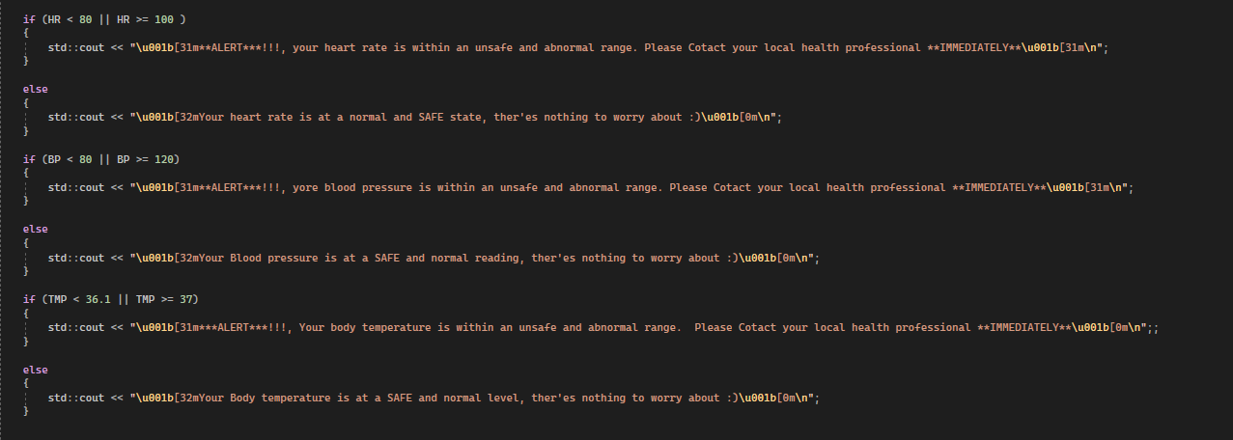

1. An additional error that was uncovered was that after the summary of the users' vital results were displayed the application would close, without giving the user a chance to view the results properly, this was solved by including a while loop to ask the user if they’d like to re-run the program. This solved the issue because it didn’t allow the program to close until after the user has selected whether they’d like to re-run it or not, this means that the results are presented to the user before they’re given the option to close it.

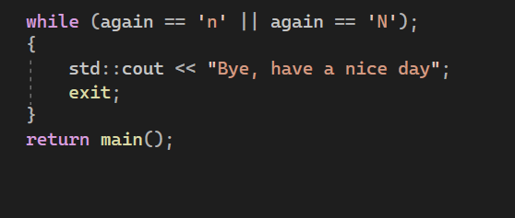

1. A further key and vital error that was identified and addressed during testing was that when inputting temperature, decimal values weren’t accepted, this meant that if the users temperature reading was a decimal the program would crash because it was expecting an integer rather than a float. This was fixed by declaring the value for TMP (temperature) as a float rather than int (integer).

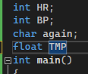

1. After Adding the float value to fix the previous error, the program wouldn’t run., I discovered that this was due to the fact that I forgot to add a semicolon to the end of the line. After adding the missing semi colon the program ran and operated fine and came out with the expected results.

